Multimedia: Personal Branding

Ameer Ismail- 218216033
group: 1F
lecturer: Blessed Mhungu
2019

QUESTIONNAIRE

- What is the company’s mission and vision?
- The mission of the company is to focus on major sets based on Technology itself such as designing and coding, and be able to answer most specialist’s needs concerning their choices. The vision of the company is to improve and become well known in its quality and offer excellent services to clients no matter where they’re situated. As well as improving and becoming professionals at designing logo’s or websites and coding java.

- How would you like to be perceived by others?
- I would like to be interpreted or transpired, firstly as a company people could trust and always offer services which will enlighten their hearts. I would also like to be well known in order to inspire us to perform much better than the previous day.

- Who is your primary target market?
- The target market are those that career choices are based on development and designing in the various I.T. fields.

- What does your company do?
- My company develop and design websites, logo’s, software development such as java coding

- What do you want your logo to say about you?
- I want my logo to describe inspiration and motivation that anyone can and is capable of reaching their goals and dreams in life. It should represent encouragement to others so that they should work harder and become best at what they do.

- How many colours would you like used in your logo?
- Approximately 3 basic colours which is red, blue and black to keep it constant and simple but with a huge and powerful representation.

- How would you describe your company or business to someone who has no knowledge of your existence?
- I would describe it as I.T. related that provides different organizations anything they enquire only based on development towards a better future.
- Do your logo have a tag-line or slogan?
- No it does not, however the name of the company which part of it is “EVOLUTION” merely represents evolving through generation which is basically a better future for all.

PERSONAS

Christopher Maurice Brown
Professional singer
Dancer
Songwriter
Actor
Entrepreneur

30 years old
United States, Virginia

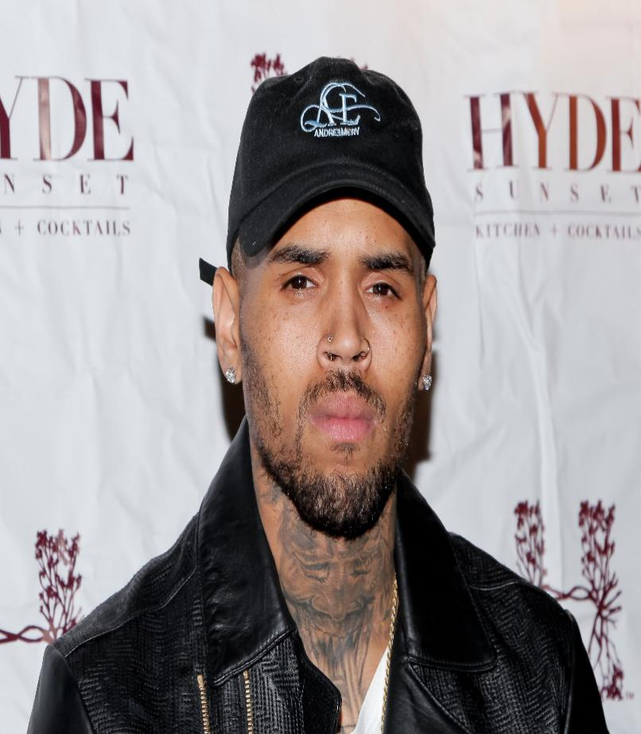
Professional artist who was involved in a church choir from a very young age. Brown became the first male artist as a lead since Diddy in 1997 to have his debut single top the chart.
He has pursued his acting career, and his personal life has been publicised. He has also sold over 140 million records worldwide, making him one of the world’s best-selling music artist.
He had major issues in his household but that did not stop him for reaching his goals.
Music always presented his life from the beginning of his childhood and today he is a role model to most.

Dwayne Douglas Johnson
Actor
Producer
Professional wrestler

47 years old
United States, California

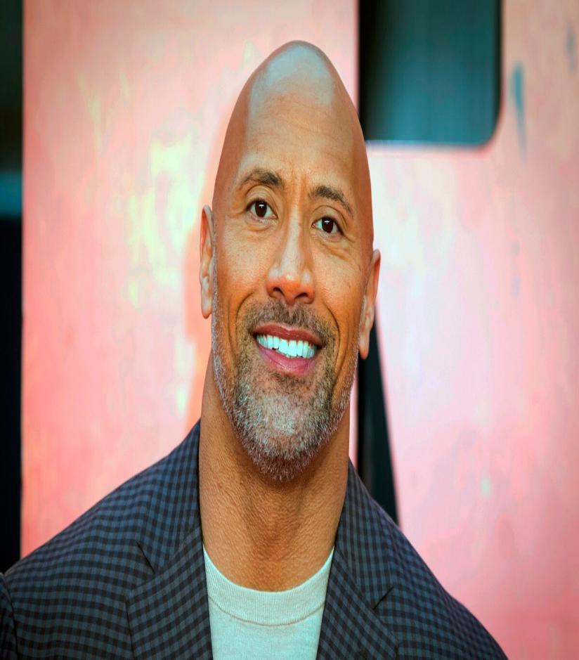
A professional who has grossed over $3.5 billion in North America and over $10.5 billion worldwide. He is one of the highest-grossing box-office stars of all time.
He rose to prominence after developing a charismatic persona of a boastful trash talking wrestler named the Rock.
He is known to be in various shows, as well as being a producer which ranks him among the world’s highest paid actors.
He went through difficulty as well

Competitor analysis

Being one of many IT multimedia and development company’s or brands, the competition are exceedingly high on becoming so called “The best”. There might be weak points as well as stronger ones, but each and every one are trying their utmost best to exceed the next. So what makes me better or different?
For me to strive just like that is no big deal because anyone can do it. I strive to achieve excellence in whatever I do, upon going that extra mile and beyond to perfect my relationship with the work itself and to perfect my relationship with clients so that encouragement rises. I strive for teamwork to make sure we all rise equally and we all become the state of the art in whatever we do as a bond, none divided.

Objective strategies

- To achieve a good relationship is the first strategy for a better lifestyle
- To put in extra effort in every single thing until I know it is perfect as possible
- To not accept any negativity that will bring you down
- To stay positive and work harder than previous times for success
- To help others
- To set the trend and be the change.
- Stay humble and go for anything you desire but do not hope for it (always have alternatives choices).

The questionnaire

